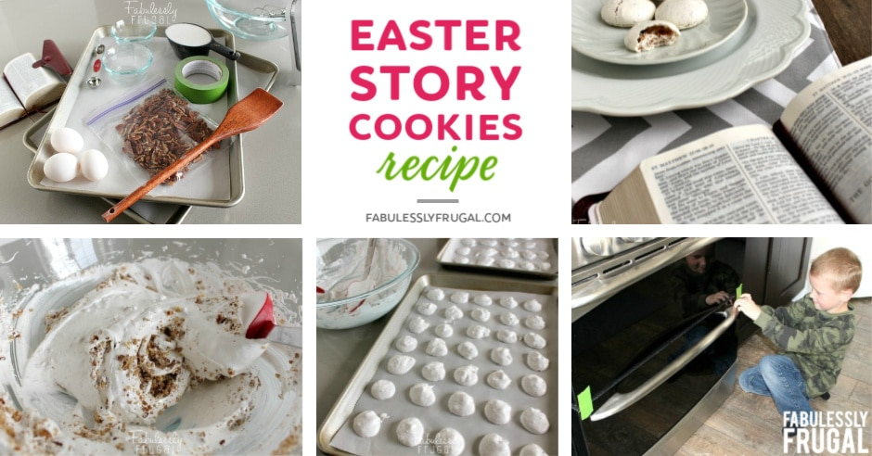

Easter Resurrection Cookies with Scripture
Making these Easter Story Cookies on the eve of Easter is a wonderful way to gather the family together and remember the reason we celebrate Easter.
The cookies are simple to make with only a few ingredients. Make them as a family and read the Bible verses that go along with the ingredients and Easter story of the resurrection. Get out your Bible and open up those scriptures!
This activity is a fun opportunity to teach your children about Jesus and Easter. Such a great Easter tradition to do as a family each year!

PREP TIME: 30 minutes | COOK TIME: over night

INGREDIENTS

COOKIES:
- 1 cup pecans (or chocolate chips)
- 1 teaspoon vinegar
- 1 teaspoon vanilla extract
- 3 egg whites (use large eggs)
- pinch of salt
- 1 cup sugar

SUPPLIES:
- resealable bag
- wooden spoon or rolling pin
- tape
- Bible
- 2 cookie sheets
- parchment paper
- teaspoon
- mixer and bowl

INSTRUCTIONS
- Preheat oven to 300 degrees.
- Place pecans in bag and let the children beat them with the wooden spoon to break them into small pieces. Explain that after Jesus was arrested He was beaten by the Roman soldiers. Read John 19:1-3.
- Let each child smell the vinegar. Put 1 teaspoon vinegar into mixing bowl. Explain that when Jesus was thirsty on the cross he was given vinegar to drink. Read John 19:28-30.
- Add egg whites to vinegar. Eggs represent life. Explain that Jesus gave His life to give us life. Read John 10: 10-11.
- Sprinkle a little salt into each child's hand. Let them taste it and brush the rest into the bowl. Explain that this represents the salty tears shed by Jesus' followers, and the bitterness of our own sin. Read Luke 23:27.
- So far the ingredients are not very appetizing, are they? Now add 1 teaspoon of vanilla and 1 cup sugar. Explain that the sweetest part of the story is that Jesus died because He loves us. He wants us to know and belong to Him. Read Psalms 34:8 and John 3:16.
- Beat with a mixer on high speed for 12-15 minutes until stiff peaks are formed. Explain that the color white represents the purity in God's eyes of those whose sins have been cleansed by Jesus. Read Isaiah 1:18 and John 3:1-3.
- Fold in broken nuts. Drop by teaspoons onto lined cookie sheets. Explain that each mound represents the rocky tomb where Jesus' body was laid. Read Matthew 27:57-60.
- Put the cookies in the oven, close the door and turn the oven OFF. (If you have a gas oven leave on for 8-10 min, then turn off.) Give each child a piece of tape and seal the oven door closed. Explain that Jesus' tomb was sealed. Read Matthew 27:65-66.
- Go to bed! Explain that they may feel sad to leave the cookies in the oven overnight, however, Jesus' followers were in despair when the tomb was sealed. Read John 16:20 & 22.
- On Easter morning open the oven and give everyone a cookie. Notice the cracked surface and take a bite. The cookies are hollow! On the first Easter, Jesus' followers were amazed to find the tomb open and empty. Read Matthew 28:1-9.

